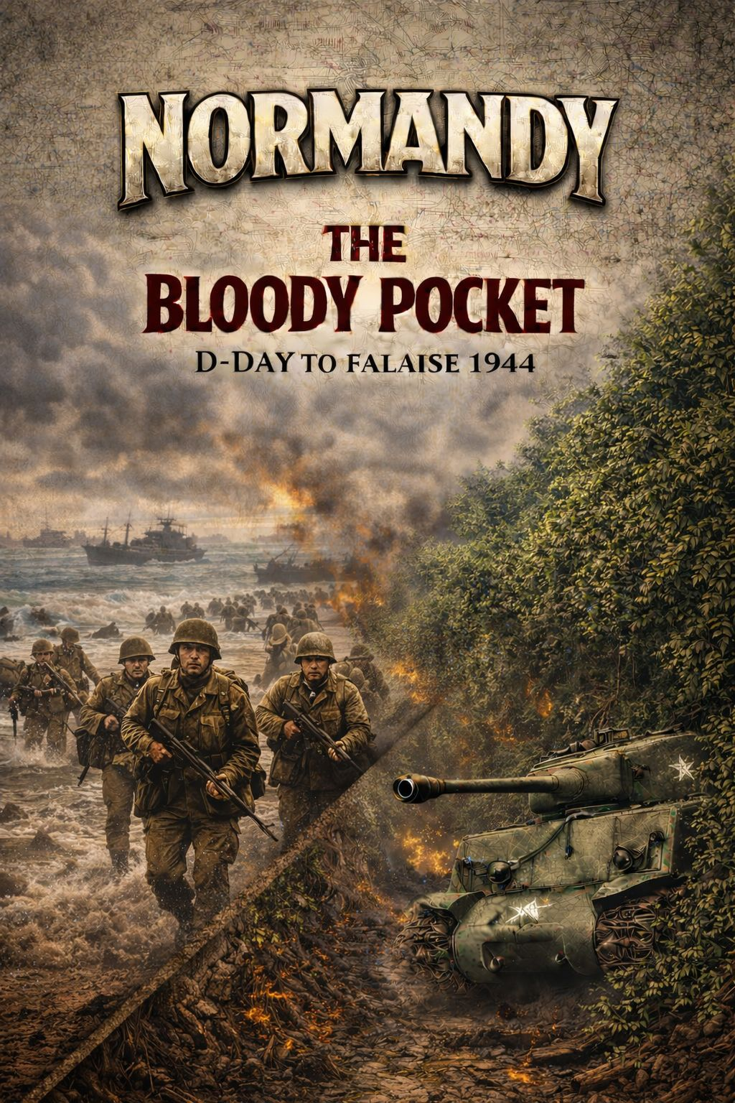
f
Playbook

TABLE OF CONTENTS

TABLE OF CONTENTS 2

Event Card Historical Background

Often is States of Siege games the historical text was printed on the cards. In Normandy: The Bloody Pocket, there was insufficient space to do this without using a prohibitively small font. Instead we present the background historical text here.

CARD 1 D-Day Landings First Wave

The operation was the largest amphibious invasion in world history, with over 160,000 troops landing on 6 June 1944. 195,700 Allied naval and merchant navy personnel in over 5,000 ships were involved.
The landings took place along a 50-mile (80 km) stretch of the Normandy coast divided into five sectors: Utah, Omaha, Gold, Juno and Sword.

CARD 2 D-Day Landings Second Wave
Very little went as planned during the landing at Omaha Beach. Difficulties in navigation caused the majority of landing craft to miss their targets throughout the day.
The defenses were unexpectedly strong, and inflicted heavy casualties on landing US troops. Under heavy fire, the engineers struggled to clear the beach obstacles, requiring a second wave assault to clear the beach

CARD 3 Carentan
The objective of the attacking American forces following D-Day was consolidation of the U.S. beachheads (Utah Beach and Omaha Beach) around the town of Carentan, and establishment of a continuous defensive line against expected German counterattacks.
The defending German force attempted to hold the town long enough to allow reinforcements en route from the south to arrive, prevent or delay the merging of the lodgments

CARD 4 21st Panzer Counter Attack
The 21st Panzer Division’s counter-attack on June 6–7 1944, was the most significant German armored response to the D-Day landings, aimed at stopping the British advance and preventing them from capturing the critical city of Caen.
Though initially successful in pushing between Sword and Juno beaches, the attack was beaten back by intense Allied anti-tank fire and Allied air superiority, resulting in heavy losses for the Germans.

CARD 5 Panzer Meyer
Kurt Meyer, nicknamed "Panzermeyer" was commanding general of the 12th SS Panzer Division Hitler Jugend. He regularly visited the front lines on a motorcycle. He sustained eighteen broken bones and four concussions during his career, testament to his daredevil personality.

CARD 6 French Resistance
The French Résistance played a significant role in facilitating the Allies' rapid advance through France following the invasion of Normandy on 6 June 1944, and the lesser-known invasion of Provence on 15 August, by providing military intelligence on the German defenses known as the Atlantic Wall and on Wehrmacht deployments and orders of battle.
The Résistance also planned, coordinated, and executed acts of sabotage on the electrical power grid, transportation facilities, and telecommunications networks.

CARD 7 Cotentin Offensive
The campaign in the Cotentin Peninsula (6-30 June 1944) was the first major Allied advance after the D-Day landings, and ended with the capture of the port of Cherbourg, seen by the Allies as one of the most important objectives of Operation Overlord.
The capture of a major port was seen as an essential part of the post D-Day build-up in France, and the seaborne assault had been extended west to Utah Beach to allow for an early advance towards Cherbourg. Captured on June 26-29, the Germans had comprehensively wrecked the Cherbourg port facilities, making it inoperable initially.

CARD 8 Villers Bocage
The battle of Villers-Bocage was the result of a British attempt to improve their position by exploiting a temporary vulnerability in the German defences to the west of the city of Caen.
The British withdrawal marked the end of the post D-Day "scramble for ground" and the start of a grinding attritional battle for Caen

CARD 9 Michael Wittmann
Michael Wittmann (April 22, 1914 – August 8, 1944) was a German Waffen-SS tank commander. Wittmann is most famous for his ambush of elements of the British 7th Armoured Division, during the Battle of Villers-Bocage on 13 June 1944.
While in command of a single Tiger tank he destroyed up to 14 tanks and 15 personnel carriers along with 2 antitank guns in the space of 15 minutes.

CARD 10 V1 Rockets
The Fieseler Fi 103, better known as the V-1 'Buzz Bomb', also colloquially known in Britain as the 'Doodlebug', was an early pulse-jet-powered example of what would later be called a cruise missile.
The V-1 was developed at Peenemünde Airfield by the German Luftwaffe during the Second World War. The first V-1 was launched at London on 13 June 1944, one week after (and prompted by) the successful Allied landings in Europe.
At its peak, over a hundred V-1s a day were fired at southeast England; 9,521 in total, decreasing in number as sites were overrun until October 1944, when the last V-1 site in range of Britain was captured by Allied forces.

CARD 11 Siege of Cherbourg
By June 20th, the American divisions were within striking distance of Cherbourg. The garrison commander, Lieutenant General Karl-Wilhelm von Schlieben, had 21,000 men but many of these were hastily drafted naval personnel or from labour units.
The fighting troops who had retreated to Cherbourg, were tired and disorganised. Food, fuel and ammunition were short. The Luftwaffe dropped a few supplies, but these were mostly items such as Iron Crosses, intended to bolster the garrison's morale.
Nevertheless, von Schlieben rejected a summons to surrender and began carrying out demolitions to deny the port to the Allies.

CARD 12 Operation Bagration
Operation Bagration was the codename for the Soviet 1944 Belorussian Strategic Offensive Operation during World War II, which cleared German forces from the Belorussian SSR and eastern Poland between 22 June and 19 August 1944.
Bagration was timed to coincide with the Allied breakout from Normandy partly in order to restrict the flow of reinforcements and supplies to the western front

CARD 13 The Great Storm
The Storm of 19-20 June 1944: The weather was always an unknown factor. Storms in the English Channel have always been violent, with the wind whipping the waves in the confined area between Normandy and England.
The great storm succeeded in doing what the Germans had not been able to do, destroy the great "mulberry" artificial harbors. It also grounded the Allied Air Forces allowing reinforcements and supplies to move around in Normandy unimpeded.
CARD 14 Operation Epsom
Operation Epsom, also known as the First Battle of the Odon, was a British offensive that took place between 26 and 30 June 1944, during the Battle of Normandy.
The offensive was intended to outflank and seize the German-occupied city of Caen, a major Allied objective in the early stages of the invasion of northwest Europe.
Preceded by attacks to secure lines of advance, Operation Epsom was launched early on 26 June, with units of the 15th (Scottish) Infantry Division advancing behind a rolling artillery barrage. Air cover was sporadic for much of the operation, as poor weather in the United Kingdom forced the last-minute cancellation of bomber support.

Extended Example of Play

Designer Notes

